# Research Question

1. What are the variables that affect hotel reservation cancelation?
2. How can we make hotel reservation cancellation better?
3. How will hotels be assisted in making pricing and promotional decision?

# Hypothesis

1. More cancellation occurs when prices are higher
2. When there is a waiting list, customers tend to cancel more frequently
3. The majority of clints are coming from offline travel agents to make their reservation.

# Analysis and Findings

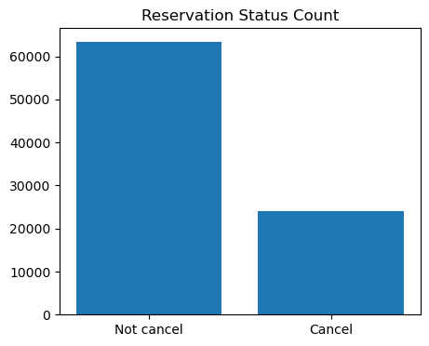

The accompanying bar graph shows the percentage of reservation that are cancelled and those that are not. It is obvious that there are still a significant number of reservations that have not been cancelled. There are still 72.5% are not cancelled and 27.5% of clints who cancelled their reservation, which has a significant impact on the hotels earning.

# Reservation status in different hotels

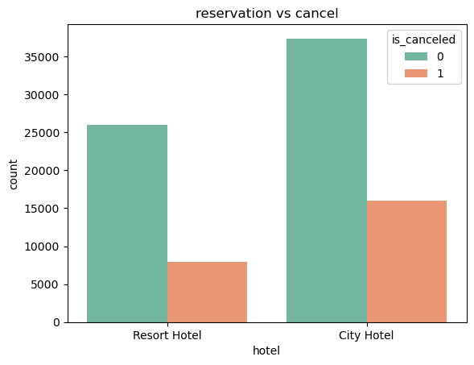

In comparison with Resort Hotel, City Hotel have more booking. It possible that Resort hotel are more expensive than City hotel. Resort hotel have less cancellation than City hotel.Resort hotel had nearly 23.5% cancellation but City hotel had 30% cancel the booking.